**Assignment #4**  
**Troubleshooting a SQL database**

This assignment is an in-class assignment that must be completed on your own without any student collaboration. Anyone caught collaborating with a student will receive **a grade of 0.**

**Feel free to use any of your previous labs and any lesson material as aids.**

**Completed & Created by:** <Insert Student Name Here>

Contents

Tasks 3

Summary of Tasks 3

What you will need to know 3

Summary of Deliverables 3

Acceptable 3

Not acceptable (will be rejected) 4

Task1 – Inserting Data – 10 Marks 6

Task2 – Database Backup Schedule – 10 Marks 7

Task3 – Fixing SQL Views – 15 Marks 8

Task4 – Fixing Stored Procedures – 10 Marks 9

Task5 – Fixing Stored Procedures v2 – 15 Marks 10

Task6 – Investigate Assignment4.exe – 15 Marks 11

Appendix 12

Assignment4.exe.confg examples: 12

# Tasks

Below is a list of tasks that are to be completed by the end of class at 9:00PM. If you are late submitting the assignment you will automatically receive a deduction of 10%. Assignments not handed in by 9:30PM will **receive a grade of 0.**

Once the assignment is completed and you have successfully uploaded it to eConestoga you can leave. Note – that you can not help other students with their assignments. If you do you will receive a grade of 0 on assignment4.

## Summary of Tasks

1. Download the Assignment4.zip file on to your SQL Server.
   1. Note the location you of where you extracted the SQL Server
2. Restore the Assignment4.bak database to your SQL Server.
3. Make sure the Assignment4.exe utility runs successfully on your SQL Server.
   1. To run this utility:
      1. Open a command prompt as Administrator
      2. Navigate to the directory that you extracted the Assignment4.exe
      3. Type Assignment4.exe
      4. Run step1. You should see no errors in the log.txt or in the console.
4. Perform all the Troubleshooting tasks below.

## What you will need to know

In order to successfully complete this assignment, you will need to be familiar with all of the labs & lectures that have been performed up until this point.

## Summary of Deliverables

Written Tasks & Screenshots must be pasted into this assignment document. You will only be allowed to submit a single word document into eConestoga.

Screenshots should be taken from your Conestoga PC and must include your SQL ServerName

Here are examples of screenshots.

### Acceptable

1. VMServer name is present
2. SQL Server Name and Instance are present
3. SQL query is present & exists
4. Message panel present and visible

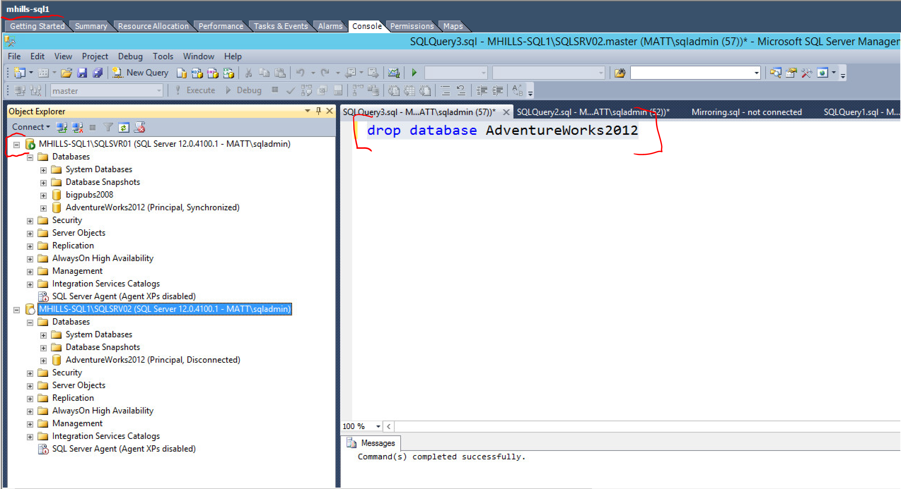

Figure 1

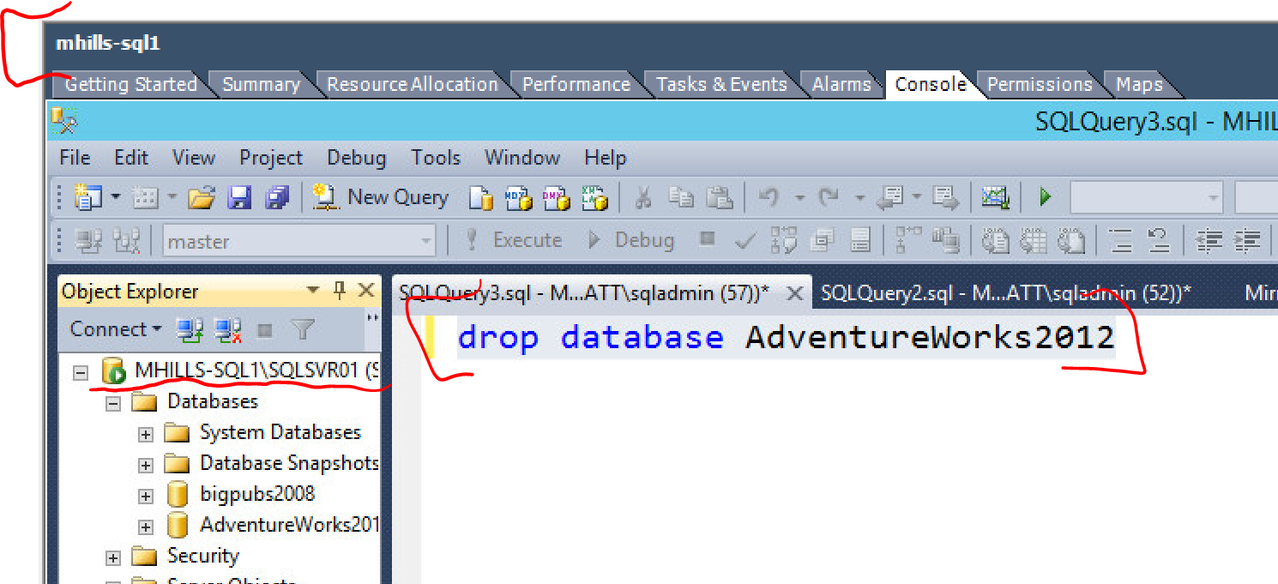

Figure 2

### Not acceptable (will be rejected)

1. VMServer name is not present
2. SQL Server Name and Instance are not present

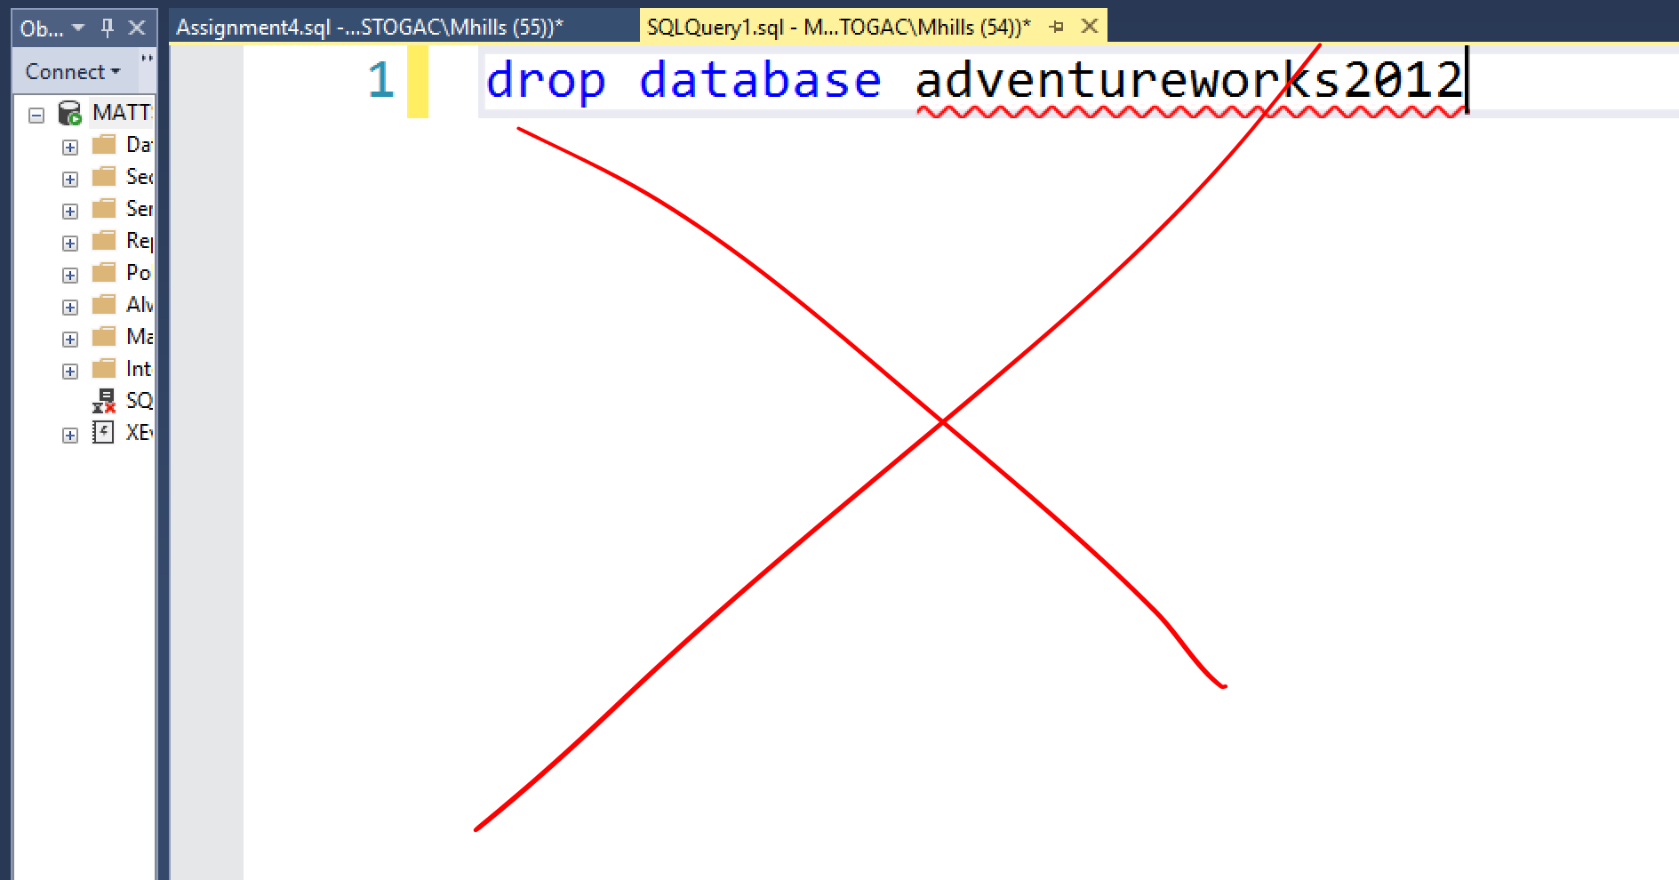

## Task1 – Inserting Data – 10 Marks

In this task you will need to use the Assignment4.dbo.upListActiveUsersAndSports stored procedure. You will need to locate the correct table(s) and **insert** data in to the Assignment 4 database so that the upListActiveUsersAndSports returns the result data as found in **Figure 3.**

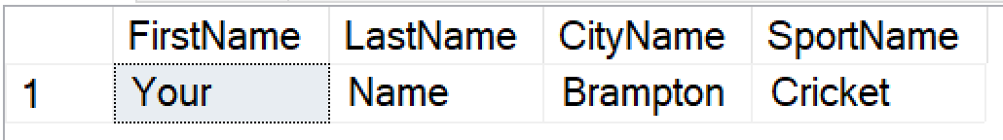Figure 3

**Deliverables**

* Provide a screenshot below this line of the T-SQL query used to insert data to the table (all 3 tables).
* Provide a screenshot of the results from upListActiveUsersAndSports stored procedure.

Screenshots:

## Task2 – Database Backup Schedule – 10 Marks

In this task you will use the SSMS to create a backup plan for the Assignment4 Database that will run automatically.

* Using the SSMS create a database backup schedule with the following parameters
* Full backup that will run on Sunday 6AM
* Differential backup that runs at 6PM Monday To Saturday
* Transaction Log backup that runs at 8AM Monday to Saturday

**Deliverables**

* Provide all screenshots below this line of the SSMS you used to create a backup schedule(s).
* Provide any screenshot(s) or the T-SQL statement that were required to perform each type of backup

Written Response:

Screenshot(s):

## Task3 – Fixing SQL Views – 15 Marks

In this task you will create and fix views using the Assignment4 Database.

A) Using the SSMS create a view that replicates the results returned in the Assignment4.dbo.upListActiveUsersAndSports stored procure.

Here Is an example of the view results:

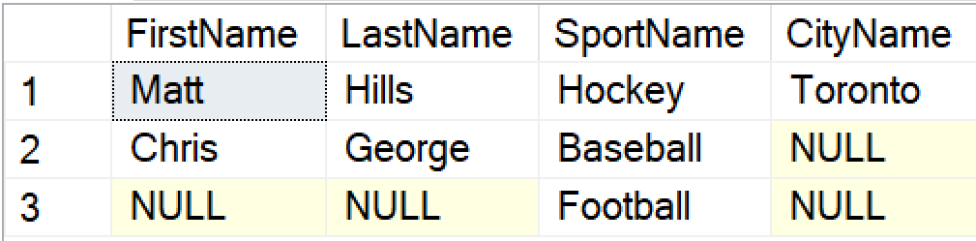

B) Using SSMS fix the existing view that you just created to only show results that have no null data. Make sure to include all steps or queries you needed to use to fix the above view.

**Deliverables**

* Provide any screenshot(s) or the SSMS or T-SQL statement that were required to perform each subtask

1. View:
2. Fixed View:

## **BONUS** Task4 – Fixing Stored Procedures – 10 Marks

Investigate why the upp_AddJobs stored procedure does not properly insert the following SQL data into the database:



**Deliverables**

* Provide a written statement of what you would to fix how the data gets added with the Upp_AddJobs stored procedure. Be sure to include T-SQL statements that support your recommendations.
* For example if you have to modify an object in SQL, provide the T-SQL statement that would successfully execute that modification.

Written Response:

## Task5 – Fixing Stored Procedures v2 – 15 Marks

Investigate why the stored procedure **Assignment4.dbo.upProcessStudentIDs** fails to run.

**Deliverables**

Why did the stored procedure fail to run?  
What step(s) did you take to learn why the stored procedure fail?  
Provide screenshots and/or T-SQL statements you used to discovery the issue.  
Provide screenshots and/or T-SQL statements you used to correct the issue.

Written Response:

Screenshot(s):

## Task6 – Investigate Assignment4.exe – 15 Marks

In this task you will use the Assignment4.exe to connect to your SQL Server and allow it to query and modify you Assignment4.exe database.

1. Navigate to where you downloaded & extracted the assignment4.exe & Assignment4.exe.config files using the command prompt.
2. Using notepad.exe update the Assignment4.exe.config to support your SQL Server Configuration. To see examples of the Assignment4.exe.config look at the end of this document.
3. Once configured run assingment4.exe.
4. In the menu select #1. Ensure that there are no errors in the log.txt or on the screen output.
5. If no errors exist, you can begin to start investigating what happens to the SQL Database when #1 is select in the Assignemnt4.exe menu.

*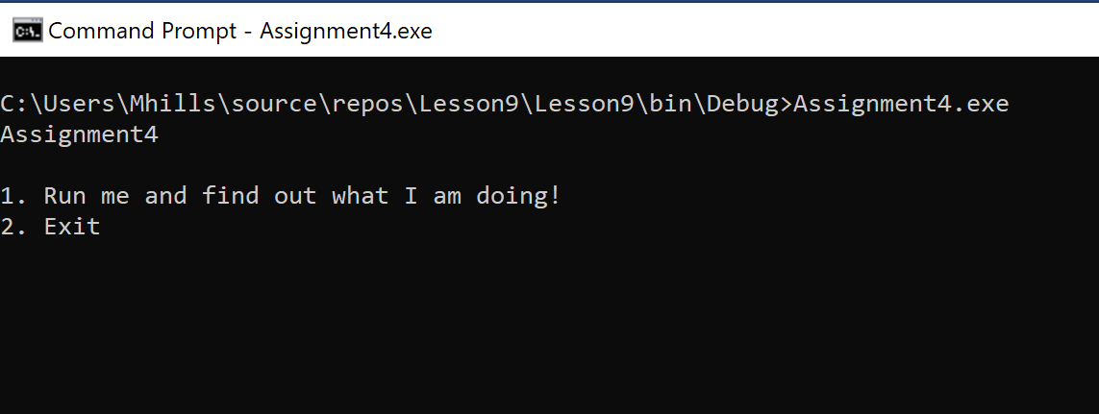  
Figure 4*

**Deliverables**

Screenshot(s) of what investigation steps were taken to understand what the Assignment4.exe application was doing with the Assignment4 database.

## Appendix

### Assignment4.exe.confg examples:

**Authentication: Windows Trusted**

<add name="Assignment4"

connectionString="Data Source=localhost\SQLInstance,1433;Network Library=DMSSOCN;Initial Catalog=master;Integrated Security=True"/>

ServerName: localhost  
InstanceName: SQLInstance  
SQL Port: 1433

**Authentication: SQL Authentication**

<add name="Assignment4"

connectionString="Data Source=localhost\SQLInstance,1433;Network Library=DMSSOCN;Initial Catalog=master;User Id=sa;Password=password"/>

ServerName: localhost  
SQL Port: 1433  
InstanceName: SQLInstance  
user: sa  
Password: password